Variance

Variance is a number that tells us how spread out the values in a data set are from the mean (average). It shows whether the numbers are close to the average or far away from it.
- If the variance is small, it means most numbers are close to the mean. If the variance is large, it means the numbers are spread out more widely.
- A higher variance indicates greater variability, meaning the data is spread, while a lower variance suggests the data points are closer to the mean.
The following image depicts the variance in a normal distribution, illustrating how data points are spread around the mean (μ).
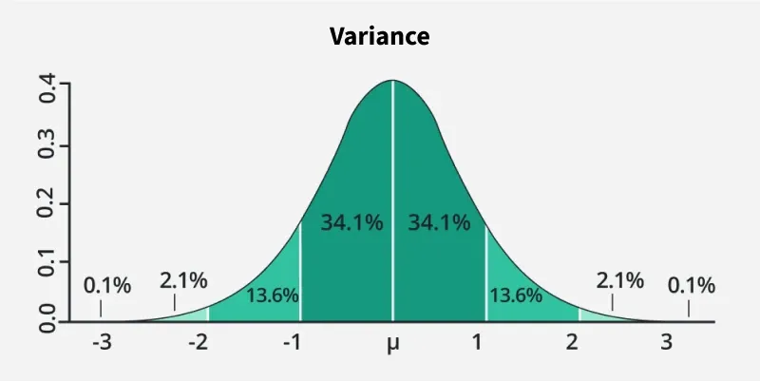
- It shows the probability density across different standard deviations (σ) from the mean, with the curve becoming wider as variance increases and narrower as variance decreases.
- The image highlights key areas, where 68.2% of the data falls within ±1 standard deviation, 95.4% within ±2, and 99.7% within ±3, following the Empirical Rule.
- The larger the variance (σ²), the more spread out the data, making the curve flatter.
Variance Symbol
- The symbol for variance is typically represented by the Greek letter sigma squared (σ²) when referring to the population variance.
- For sample variance, it is often denoted by s².
Formula for Calculating Variance
The formula used for calculating the Variance is discussed in the image below:

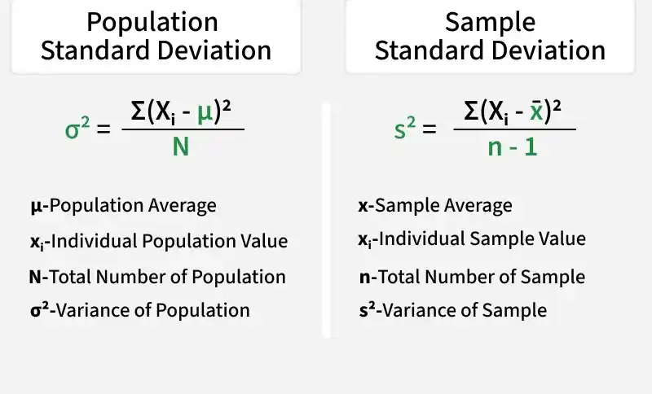
Steps to Calculate Variance
In general, variance means population standard variance. The steps to calculate the variance of a given set of values are,
- Step 1: Calculate the mean of the observation using the formula (Mean = Sum of Observations/Number of Observations)
- Step 2: Calculate the squared differences of the data values from the mean. (Data Value - Mean)²
- Step 3: Calculate the average of the squared differences of the given values, which is called the variance of the data set.
(Variance = Sum of Squared Differences / Number of Observations)
Types of Variance
We can define the variance of the given data in two types,
- Variance for Population
- Variance for Sample
Population Variance
Population variance is used to find the spread of the given population. The population is defined as a group of people and all the people in that group are part of the population. It tells us about how the population of a group varies with respect to the mean population.
When we want to find how each data point in a given population varies or is spread out, then we use the population variance. It is used to give the squared distance of each data point from the population mean.
Population Variance Formula
The formula for population variance is written as,
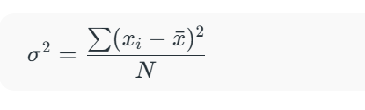
where,
- σ² is population variance,
- x̄ is the mean of the population dataset,
- N is the total number of observations.
Population variance is mainly used when the entire population's data is available for analysis.
Example: Find the Population variance of the data [5, 7, 9, 10, 14, 15].
Solution:
Mean(xˉ) = (5 + 7 + 9 + 10 + 14 + 15) / 6 = 10

Data(x) | (x−xˉ)2 | Value of (x−xˉ)2
5 | (5 - 10)² | 25
7 | (7 - 10)² | 9
9 | (9 - 10)² | 1
10 | (10 - 10)² | 0
14 | (14 - 10)² | 16
15 | (15 - 10)² | 25
Variance = ( 25 + 9 + 1 + 0 + 16 + 25) / 6 = 76/6 = 12.67
Thus, the variance of the data is 12.67
Sample Variance
If the population data is very large, it becomes difficult to calculate the population variance of the data set. In that case, we take a sample of data from the given dataset and find the variance of that dataset, which is called sample variance.
While calculating the sample mean, we make sure to calculate the sample mean, i.e., the mean of the sample data set, not the population mean. We can define the sample variance as the mean of the squares of the differences between the sample data points and the sample mean.
Sample Variance Formula
The formula of the Sample variance is given by,
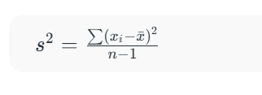
where,
- s2 is sample variance,
- x̄ is the mean of the sample dataset,
- n is the total number of observations.
Sample variance is typically used when working with data from a sample to infer properties about
Example: Find the Sample variance of the data {4, 6, 8, 10}
Solution:
Mean(xˉ) = (4 + 6 + 8 + 10) / 4 = 7
Data(x) | (x−xˉ)2 | Value of (x−xˉ)2
4 | (4 - 7)² | 9
6 | (6 - 7)² | 1
8 | (8 - 7)² | 1
10 | (10 - 7)² | 9
Variance = (9 + 1 + 1 + 9) / (4 - 1) = 20/3
Thus, the variance of the data is 20/3

